
Eastington Primary School

Offer of Early Help

Oct 2025

Through the Graduated Pathway of Early Help and Support, we utilise a range of approaches and services to support children.

Early identification of risk is important to safeguarding all children/young people and adults.

Any child may benefit from early help, but all school staff are particularly alert to the potential need for early help for a child who:
- is disabled or has certain health conditions and has specific additional needs;
- has special educational needs (whether or not they have a statutory Education,
Health and Care Plan);
- has a mental health need;
- is a young carer;
- is showing signs of being drawn in to anti-social or criminal behaviour, including gang involvement and association with organised crime groups or county lines;
• is frequently missing/goes missing from care or from home;
- is at risk of modern slavery, trafficking, sexual or criminal exploitation;
- is at risk of being radicalised or exploited;
- has a family member in prison, or is affected by parental offending;
- is in a family circumstance presenting challenges for the child, such as drug and alcohol misuse, adult mental health issues and domestic abuse;
- is misusing drugs or alcohol themselves;

Universal support for children in our school include:
- Qualified SENDCo with a strong understanding of ACES (Adverse Childhood Experiences), attachment and the Graduated Pathway, which allows us to identify and support children with gaps in their emotional development.
- A DSL who leads safeguarding well and is well trained.
- All staff, including the DSL, have been trained on the Graduated Pathway. Staff receive ongoing updates on potential risks such as Domestic Abuse, Honour Based Abuse, Forced Marriage, Female Genital Mutilation, Child Sexual Exploitation etc. and know what to do should they identify a person at risk.
- A comprehensive, up-to-date PSHE curriculum is in place which is updated in light of concerns raised on a National level. The curriculum covers many aspects of keeping young people safe, healthy, resilient and aware of the world around them so that they can make informed decisions. It is age specific and progressive and supports developing, healthy and positive relationships developmental so children’s understand develops as they become older. We teach cover aspects such as age-appropriate Sex Education, Gender Equality and equity, Drugs, Keeping Safe (e-safety, personal safety etc.), Emotional Wellbeing, Relationships and Healthy Living, through the our PSHE curriculum (supported by Coram Scarf Life Education).
- A rigorous e-safety curriculum, including a yearly unit on how to keep safe online with the Computing curriculum, Y4 children attending ‘In the Net’ to explore ways of keeping themselves safe and Y6 children working with the local BEAT Police Officer on Online Safety & peer pressure.
- The biannual KS2 online pupil survey and pupil conferencing with KS1 pupils – action taken in response to the survey/conferencing
- Links with the Early Help Co-ordinator for advice, guidance and support
- ELSA (Emotional Literacy Support Assistant) trained member of staff on site.

All staff are aware of their responsibilities for Early Help.
The Designated Safeguarding Lead, SENDCo and Deputy Safeguarding leads are responsible for coordinating the offer of Early Help.
Once a referral has been made, the designated safeguarding lead (or deputy) will generally be responsible for liaising with other agencies and setting up an inter-agency assessment as appropriate.
Staff may be required to support other agencies and professionals in an early help assessment, in some cases acting as the lead professional.
Any such cases will be kept under review and consideration given to a referral to children’s social care for assessment for statutory services, if the child’s situation does not appear to be improving or is getting worse.

Useful advice and information can be found online, including:
- To find out more about Early Help, please see the Gloucestershire’s graduated pathway and Early Help information.
https://www.gloucestershire.gov.uk/early-years-service/information-for-providers/graduated-pathway-of-early-help-and-support/#:~:text=The%20Graduated%20Pathway%20is%20Gloucestershire's,emotional%20needs%20or%20a%20disability.
- Gloucestershire Family Families Directory : https://www.glosfamiliesdirectory.org.uk/kb5/gloucs/glosfamilies/home.page
- Information from Government on many relevant areas: www.gov.uk
- Information from NSPCC on many relevant areas: www.nspcc.org.uk

Below is a directory of services/information which can support professionals, school workers and parents:

Bullying including Cyberbullying/E-Safety
We work hard as a school community to support positive relationships at all levels. Through our e-safety curriculum, children are taught how to behave responsibly online and how to seek advice if they have any concerns. This is also taught in our PSHE curriculum and assemblies.
However, children can sometime display bullying behaviours and children can abuse other children. For full information on these issues please see our Anti-Bullying & Harassment Policy and Safeguarding Policy. We have worry Boxes are in every room for the children to report any concerns.

Helpful websites for teaching staff and parents:
- PACE (parents against child exploitation) UK is a useful website to engage parents with e-safety issues. www.paceuk.info/
- www.thinkuknow.co.uk/parents (excellent resources)
- http://educateagainsthate.com
- www.internetmatters.org
- https://ico.org.uk

Child Sexual Exploitation (CSE)
The revised definition of CSE states that: Child sexual exploitation is a form of child sexual abuse. It occurs where an individual or group takes advantage of an imbalance of power to coerce, manipulate or deceive a child or young person under the age of 18 into sexual activity (a) in exchange for something the victim needs or wants, and/or (b) for the financial advantage or increased status of the perpetrator or facilitator. The victim may have been sexually exploited even if the sexual activity appears consensual. Child sexual exploitation does not always involve physical contact; it can also occur through the use of technology.

Sexual exploitation of children and young people under 18 involves exploitative situations, contexts and relationships where young people (or a third person or persons) receive ‘something’ (e.g. food, accommodation, drugs, alcohol, cigarettes, affection, gifts, money) as a result of them, and/ or another or others performing on them, sexual activities. Child sexual exploitation can occur through the use of technology without the child’s immediate recognition; for example, being persuaded to post sexual images on the internet/ mobile phones without immediate payment or gain. In all cases, those exploiting the child/ young person have power over them by virtue of their age, gender, intellect, physical strength and/ or economic or other resources. Violence, coercion and intimidation are common, involvement in exploitative relationships being characterised in the main by the child or young person’s limited availability of choice resulting from their social/ economic and/ or emotional vulnerability.
- A screening toolkit will be completed if there are concerns. On completion, this will be sent the Gloucestershire MASH unit.
- The Hollie Gazzard trust are working alongside GDASS to support teenagers who may been subject to relationship abuse.

Helpful websites for teaching staff and parents:
- Info for practitioners https://www.gov.uk/government/publications/what-to-do-if-you-suspect-a-childisbeing-sexually-exploited
- Parents Against Child Exploitation. www.paceuk.info/

Children (or young people) with multiple needs - requiring multi-agency input / assessment.
Gloucestershire Early Help Partnership (co-ordinated by Families First Plus) provide multi-agency support for children and families. A phone call to discuss a possible referral is helpful before making written referral. Parents must consent to a referral. School seek support when appropriate. Referrals go to the Early Help Partnership (representation from Education, health, social care etc. and referring agencies are encouraged to attend. All agencies should view themselves as part of this Early Help Partnership. The referral meeting is a multi-agency discussion to decide the best way forward.
These teams are made up of the following professionals Early Help co-ordinators, Community Social Worker and Family Support Workers. They all work together from one base so they can recognise and respond to local needs and act as a focal point for co-ordinating support for vulnerable children, young people and their families.
Support provided includes: Support for school and community based lead professionals working with children and families; Collaboration with social care referrals that do not meet their thresholds, to co-ordinate support within the community; Advice and guidance from a social work perspective on a 'discussion in principle basis’; Signpost children with disabilities and their families to access activities and meet specific needs; Advice and guidance to lead professionals and the provision of high quality parenting and family support services to families. We are in the Stroud area.

Helpful websites for teaching staff and parents:
- Early Help Partnership/Families First Plus:
Gloucester: gloucesterearlyhelp@gloucestershire.gov.uk
Tel: 01452 328076;

- Stroud: stroudearlyhelp@gloucestershire.gov.uk
Tel: 01452 328130;
- Tewkesbury: tewkesburyearlyhelp@gloucestershire.gov.uk
Tel: 01452 328251;
- Cotswold: cotswoldearlyhelp@gloucestershire.gov.uk
Tel: 01452 328101;
- FOD: forestofdeanearlyhelp@gloucestershire.gov.uk
Tel: 01452 328048;
- Cheltenham: cheltenhamearlyhelp@gloucestershire.gov.uk
Tel: 01452 328160

Domestic Abuse
Any incident or pattern of incidents of controlling, coercive, threatening behaviour, violence or abuse between those aged 16 or over who are, or have been, intimate partners or family members regardless of gender or sexuality. The abuse can encompass, but is not limited to: psychological, physical, sexual, economical and/or emotional.
Helpful websites for teaching staff and parents
- GDASS www.gdass.org.uk
- The Hollie Gazzard trust are working alongside GDASS to support teenagers who may been subject to relationship abuse too.
- www.gov.uk/guidance/domestic-violence-and-abuse

Drugs - Dangerous Drug Network (County Lines)
- We are aware of the risks of the Dangerous Drugs Network (DDN) to our children and families, particularly those seen as vulnerable due to individual circumstances e.g single parents, people who are drug or alcohol dependent.
- Concerns will be shared with the DSL and forwarded to the DDN helpline on the Gloucestershire Constabulary website: https://www.gloucestershire.police.uk/contact/af/contact-us/

School staff will look out for changes such as:
- New friends that have the potential to be a bad influence
- Behaving differently or out of character
- Developed a new attitude?
- Unexplained injuries?
- Continually late to school or forgetting to do homework?
- Continually tired
- New expensive possessions such as trainers, jewellery, mobile phone or designer clothes
- Become withdrawn
- Changes at home that might make them more vulnerable

Drugs
Helpful websites for teaching staff and parents:
- www.infobuzz.co.uk Service to support families where substance misuse has been identified.
- https://www.gov.uk/government/publications/drugs-advice-for-schools
- Nelson Trust for family support: https://nelsontrust.com/ Alcohol misuse https://www.alcoholics-anonymous.org.uk/
- Narcotic anonymous https://ukna.org/

Early Help Offer from Local Authority and Multi-Agency Support
Gloucestershire has an Early Help Partnership. These groups are supported by Families First Plus teams. To access support, a Request for Support form needs to be completed along with a Consent form from the family.
Helpful websites for teaching staff and parents:
- Additional services involved include the Family Information Service - access to online directory of services here www.glosfamiliesdirectory.org.uk
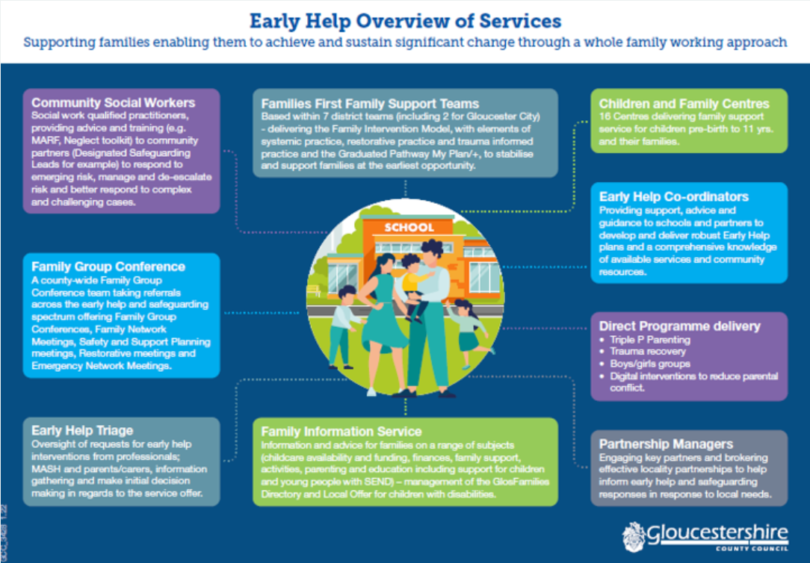

Fabricated or Induced Illness
For information on behaviours and motivation visit:
- www.nhs.uk/Conditions/fabricated-or-induced-illness
- To find Government information: https://www.gov.uk/government/publications/safeguarding-children-inwhomillness-is-fabricated-or-induced

Faith Abuse
Helpful websites for teaching staff and parents:
- https://www.gov.uk/government/publications/national-action-plan-totacklechild-abuse-linked-to-faith-or-belief
- Judith Knight: Diocese of Gloucester Head of Safeguarding/faith abuse.
01452 835526/07801 750664 jknight@glosdioc.org.uk

Female Genital Mutilation (FGM)
Professionals in all agencies, and individuals and groups in relevant communities, need to be alert to the possibility of a girl being at risk of FGM, or already having suffered FGM. There is a range of potential indicators that a child or young person may be at risk of FGM, which individually may not indicate risk but if there are two or more indicators present this could signal a risk to the child or young person. Victims of FGM are likely to come from a community that is known to practise FGM. Professionals should note that girls at risk of FGM may not yet be aware of the practice or that it may be conducted on them, so sensitivity should always be shown when approaching the subject.

Whilst all staff should speak to the designated safeguarding lead (or deputy) with regard to any concerns about female genital mutilation (FGM), there is a specific legal duty on teachers.
- If a teacher, in the course of their work in the profession, discovers that an act of FGM appears to have been carried out on a girl under the age of 18, the teacher must report this to the police either through the Public Protection Bureau 101 or 999 if it is appropriate to do so.
- For information https://www.gov.uk/government/publications/female-genital-mutilation-guidelines

Forced Marriage
A marriage in which one or both spouses do not (or in the case of some adults with support needs, cannot) consent to the marriage and duress involved. Duress can include physical, psychological, financial, sexual, emotional pressure.
- Single point of contact for Forced Marriage in Gloucestershire:
https://www.gov.uk/guidance/forced-marriage

Gangs and Youth Violence
Helpful websites for teaching staff and parents:
- Contact the Avenger Task Force at Gloucestershire Constabulary
- For information: https://www.gov.uk/government/uploads/system/uploads/attachment_data/fil e/
418131/Preventing_youth_violence_and_gang_involvement_v3_March2015.pdf

Gender-based Violence/Violence against Women and Girls (VAWG)
Helpful websites for teaching staff and parents:
- https://www.gov.uk/government/policies/violence-against-women-and-girls
- Support for Trans Gender and Non Binary community https://www.tht.org.uk/hivand-sexual-health/sexual-health/trans-people/resources
- Gender support lines https://www.supportline.org.uk/problems/gender-identity/ Sexual Health and Well Being including assault and rape support https://www.hopehouse.nhs.uk/

Honour Based Violence
The police have made a high priority to help communities tackle this and hate crime.
- Honour Network Helpline 0800 5999247

Mental Health Concerns
We take the mental health of our children and families seriously. Developing positive metal health is taught explicitly through KS2 in our PSHE curriculum (supported by Coram Life Education) and in assemblies. Y5 children have specific training on becoming Sports and Well-Being Leaders to support others too.

Helpful websites for teaching staff and parents:
- www.onyourmindglos.nhs.uk – a newly launched website by Gloucestershire as part of the Future in Mind Programme. This website is good for young people, parents and professionals in terms of help with mental health issues and where to go for help.
- Referral to CYPS (Gloucestershire’s mental health services) via your own GP.
- For children/young people/adults with existing mental health difficulties concerns should be discussed with the existing medical professionals/consultant psychiatrists. In an emergency call 999 or 111.
- Referral to school nurses may be appropriate.
- CYPS* Practitioner advice line for professionals - tel: 01452 894272.
- CAMHS https://www.ghc.nhs.uk/our-teams-and-services/cyp-glos/
- Tic+ 01594 372777
- Family Lives https://www.familylives.org.uk/
- Mind https://www.mind.org.uk/
- Young Minds Matter https://www.ghc.nhs.uk/our-teams-and-services/cypglos/young-minds-matter/

Private Fostering
A private arrangement between a child’s parent and the foster parents. Children are privately fostered if they live with someone for 28 days or more, or are placed with the intention that they will stay for 28 days or more.
Private fostering applies to children under 16 years of age (or 18 if they are disabled) and doesn’t include arrangements made between close relatives. A close relative is an aunt, uncle, step-parent, grandparent or sibling, but not a cousin, great aunt/uncle or a family friend.
The law requires the private foster carer to notify the Local Authority of the agreement at least 6 weeks before the arrangement or within 48 hours of the child’s arrival if it is an emergency placement.

Helpful websites for teaching staff and parents:
- If our school becomes aware of a private fostering arrangement, we will contact the Children and Families Helpdesk (01452 426565) to ensure that the LA have been notified.
https://www.gloucestershire.gov.uk/fostering/types-of-fostering/private-fostering/
- https://www.gov.uk/government/publications/children-act-1989-privatefostering

Preventing Radicalisation and Extremism/hate (PREVENT duty)
HM Government PREVENT duty: As of 1 July 2015 duty in the Counter-terrorism and security act 2015 for specified authorities (including all schools) to have due regard to the need to prevent people being drawn in to terrorism. All staff at Eastington have had training on radicalisation and extremism and when to refer to the Channel panels. (HM government online training)

Helpful websites for teaching staff and parents:
- If you see extremist / terrorist content online, please report it via:
https://www.gov.uk/report-terrorism
- Gloucestershire Safeguarding Children’s Board www.gscb.org.
- www.educateagainsthate.com is the government website providing information and practical advice for parents, teachers and schools leaders on protecting children from radicalisation and extremism.
- Gloucestershire Safeguarding Children’s Board have published a PREVENT pathway for professionals to refer to.
- Key contacts: Gloucestershire Constabulary PREVENT officer: tel 101
- Prevent@gloucestershire.police.uk
- Anti-Terrorist Hotline: tel 0800 789 321
- The ‘Advice on the Prevent duty’ written by the Department for Education explains what governors and staff can do if they have any concerns relating to extremism. The Department for Education has also set up a telephone helpline (020 7340 7264) to enable people to raise concerns directly. Concerns can also be raised by email to counter.extremism@education.gsi.gov.uk.

Sexting
Helpful websites for teaching staff and parents:
- https://www.nspcc.org.uk/keeping-children-safe/online-safety/sexting-sending-nudes/ (NSPCC website).
- Gloucestershire Police have a small sexual exploitation team, visit https://www.gloucestershire.police.uk/

Teenage Relationship Abuse
Helpful websites for teaching staff and parents:
- https://www.gov.uk/government/collections/this-is-abuse-campaign
- Hope House https://www.hopehouse.nhs.uk/

Trafficking
Helpful websites for teaching staff and parents:
- https://www.gov.uk/government/publications/safeguarding-children-who-mayhavebeen-trafficked-practice-guidance

Universal source of help for all families in Gloucestershire
Helpful websites for teaching staff and parents:
- Gloucestershire Family Information Service (FIS)
Gloucestershire Family Information Service (FIS) advisors give impartial information on childcare, finances, parenting and education. FIS are a useful source of information for parents and professionals. They support families, children and young people aged 0-19 years of age (25 for young people with additional needs) and professionals working with these families. They can help link parents up with other organisations that might be able to help or provide the information themselves e.g. parents could ask them about holiday clubs for your children across Gloucestershire.
Contact the FIS by emailing:familyinfo@gloucestershire.gov.uk
Or telephone: (0800) 542 0202 or (01452) 427362.
- Gloucestershire Family Information Service (FIS)
FIS also have a website which has a wealth of information to support many issues such as childcare and support for children with disabilities.
- For information for Children and Young People with Special Education Needs and Disabilities (SEND) go to the SEN and Disability ‘Local Offer’ website: http://www.glosfamiliesdirectory.org.uk/kb5/gloucs/glosfamilies/home.page

Youth Support Team (YST):
The Youth Support Team provide a range of services for vulnerable young people aged between 11 - 19 (and up to 25 for young people with special needs), including:
- Youth offending
- Looked after children
- Care leaver's support services (for those aged 16+)
- Early intervention and prevention service for 11 -19-year-olds
- Support for young people with learning difficulties and/or disabilities
- Positive activities for young people with disabilities
- Support with housing and homelessness
- Help and support to tackle substance misuse problems and other health issues
- Support into education, training and employment
- Support for teenage parents
- For General Enquiries: T: 01452 547540 E: info.glos@prospects.co.uk
- To make a referral: T: 01452 426565 E: fasttrackteam@prospects.co.uk

