Eastington Primary School

Attendance Policy: Coronavirus Addendum

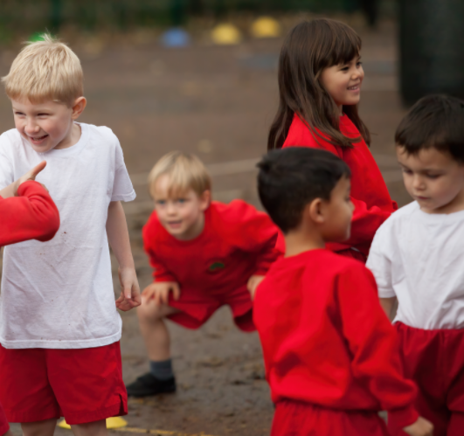

October 2021

Aims and scope
We are committed to meeting our obligations with regards to school attendance by:
- Ensuring every pupil has access to full-time education to which they are entitled
- Acting early to address patterns of absence
- Supporting parents/carers and pupils who are concerned about the return to school due to coronavirus

This addendum sets out changes to our normal attendance policy and should be read in conjunction with that policy. Unless covered here, our normal attendance policy continues to apply.
We may need to amend or add to this addendum as circumstances or official guidance changes.

Attendance expectations
In March 2020, when the coronavirus (COVID-19) pandemic was increasing, Government made it clear no parent would be penalised or sanctioned for their child’s non-attendance at school.
From September 2020 the circumstances changed, it was vital for all children to return to school to minimise, as far as possible, the longer-term impact of the pandemic on children’s education, wellbeing and wider development.
School attendance has been mandatory from the beginning of September 2021 . This means from this point, the usual rules on school attendance will apply, including:
- parents’ duty to secure that their child attends regularly at school
- schools’ responsibilities to record attendance and follow up absence
- the availability to issue sanctions, including fixed penalty notices in line with local authorities’ codes of conduct

It is mandatory for all pupils of compulsory school age to attend school unless:
- They have been granted an authorised absence by the school in line our normal attendance policy
- They cannot attend school due to specific circumstances related to coronavirus (see below)

Where ‘non-attendance in relation to coronavirus’ applies
We understand ‘non-attendance in relation to coronavirus’ in circumstances where a pupil’s travel to, or attendance at, school would be:
- Against guidance from Public Health England and/or the Department of Health and Social Care relating to the incidence of coronavirus or its transmission (EG: following self-isolating/ test and trace advice)
- Prohibited by any legislation or statutory directions relating to the incidence of transmission of coronavirus (EG: moving to a national lockdown)
- Pupils who have been asked to shield by a health professional – though guidance to schools has explained this is rare.

Remote learning provision and attendance
If a pupil is not attending school because of circumstances related to coronavirus such as self-isolating for a block of time, but where the pupil is not ill, the school will provide the pupil access to remote education. If this is for a short period for an individual child, learning will be provided which will utilise Oak Academy – this is because the teacher will be working full time with the class in school. In the case of lockdown, our approach and expectations regarding remote education are set out in the Remote Learning Policy found on our website – essentially our teachers/TAs will work provide the same learning for all children – a daily timetable through Google Classroom with a mix of, recorded lessons from BBC/Oak Academy etc, work, live lessons etc. Children who are vulnerable/have key worker parents will work on site to undertake the learning.

Children will be expected to engage in remote learning if at home. We have a legal duty to keep a record of, and monitor, pupil engagement with remote learning. DfE may ask for this information on our daily attendance return.
If you are struggling with remote learning, please contact the class teacher who can support prioritising learning for your child.
Whether children are working at home or at school, parents and carers will need to follow the usual procedure of calling the school if a child is ill as soon as possible at the start of the day. We will notify the teacher/TAs so they are aware. We will follow-up any pupil not attending school/engaging in home learning in the usual way.

Recording attendance
When children are working at school, we will take our attendance register at the start of the first session of each school day and once during the second session. It will mark whether every pupil is:
- Present
- Attending an approved off-site educational activity
- Absent
- Unable to attend due to ‘exceptional circumstances’ (as per our normal attendance policy)
- Unable to attend for reasons related to coronavirus (see appendix 1 for the relevant absence codes and when we will use them)
Pupils must arrive in school at their designated time slot on each school day. This may be different than our usual entry times due to staggered starts.

When working at home, teachers leading remote learning will take a register daily to acknowledge engagement in home learning through attending live lessons, sharing work etc.. This information will help us track pupil engagement and enable us to support if needed. It will also inform our daily attendance return to DfE.

Following up absence
Where any child we expect to attend school does not attend, or stops engaging in remote learnign, we will:
- Follow up on their absence with their parent or carer by phone
- Notify their social worker, where they have one, if we have concerns/are unsure of the reason for absence
If a pupil does not attend because they, and/or their parent/carer are concerned about returning to school because of coronavirus, we will work with the child/parent to support the return of the pupil. This may be via phone or face to face. The protective measures the school is taking to keep pupils safe are shared in the RA found on the website.

Monitoring arrangements
This policy will be reviewed as guidance from the LA or Department for Education is updated.

Appendix 1: pupil absence codes
The following codes are taken from the DfE’s addendum to their school attendance guidance. If not covered here, our normal attendance codes apply.

Code | Definition | Scenario
X | Not attending in circumstances relating to coronavirus (COVID-19) | Pupil has to self-isolate because they have symptoms or live with someone who does, and are waiting for their test results
I | Illness | Pupil remains unwell following a negative test result (i.e. with a different illness)
I | Illness | Pupil has to continue to self-isolate because they tested positive
X | Not attending in circumstances relating to coronavirus (COVID-19) | Pupil has to self-isolate (for 14 days) because someone they live with tested positive
X | Not attending in circumstances relating to coronavirus (COVID-19) | Pupil has to self-isolate (for 14 days) because they are a close contact of someone who tested positive
X | Not attending in circumstances relating to coronavirus (COVID-19) | Pupil has to quarantine (for 14 days) after a trip to a non-exempt country
X | Not attending in circumstances relating to coronavirus (COVID-19) | Pupil is required to shield in the case of a local lockdown, or lives with someone who is required to shield
X | Not attending in circumstances relating to coronavirus (COVID-19) | Pupil is asked not to attend in the case of local lockdown

