

**NEWSLETTER 2**

17th September 2021

Dear parents and carers,

The children have been enjoying playing together again. It has been wonderful to see older children helping the younger children and children playing together across classes again. Well done to Arlo and Jacob who had the whole school enthralled at lunch time with their giant Jenga tower – the younger children thought it must be the tallest in the world! I’m not sure that is true but it was impressive. Thanks Mrs Williams, Mrs Yorke and Miss Hathaway – our wonderful midday supervisors – for organising the play equipment and rotas for the children so they can have fun being active too.



**£1 Challenge**

The PTA and the School Council (SC) worked together to set the children a challenge over the Summer holidays with the aim of supporting the entrepreneurial spirit within and raising funds for school. Lots of children took part and we celebrated the great action that children took over the holidays in Celebration Assembly on Friday.

The children were given £1 and asked to use it to generate more money. Several children took part and ideas they thought of were brilliant. Refreshments were served, cars were washed, cakes baked, machines were built, competitions were run and words were unspoken!

The School Council were thrilled that the children took part and congratulate each one of them for their hard work. We were all impressed you gave you time and skills to support our school – we think you are all super stars!

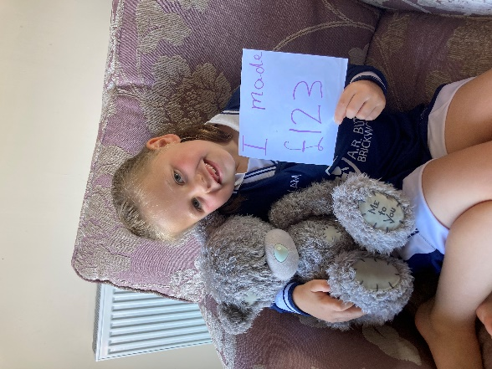 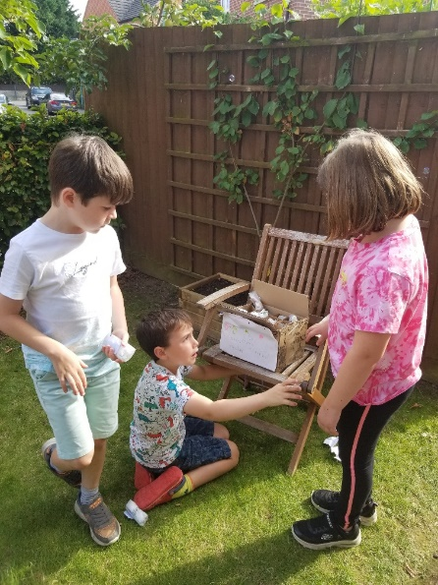

Every child who took part was celebrated in assembly and received a certificate.

Thank you to Maude on the SC for the great idea and leading the project.

|  |  |
| --- | --- |
| **Child/ren** | **Activity** |
| Cory | Cake making & Car washing |
| James | Haribu launching machine! |
| Mila | Teddy competition |
| Bethan & Jacob | Sold biscuits, cake and tea at an athletic meeting |
| Adam & Katie | Sold ice-lollies |
| Sophie | Cleaning |
| Jack | Car wash |
| Maude | Sponsored silence-3 hours |
| Otto | Cake sale |
| Marci & Tess | Guess the number of sweets in the jar |
| Addy & Jesse | Sparkle & Shine Car wash Company |
| **AMAZING TOTAL £561.63** | |

**Bikeability**

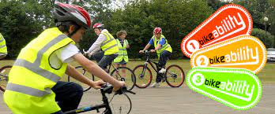The Year 6 pupils relished their safe cycle training with the Gloucestershire Road Safety Team this week. The children learned an array of skills including ensuring their bikes were safe, recognising potential road hazards, turning right and understanding the basics of the highway code. Here are some of the thoughts of the children:

Harrison: I liked learning how to ride on the roads and how to do different junctions.

Marcie: I learned what the road signs meant and what to do when I saw them.

Jack: I loved going on the roads and doing the signals.

Maisie: I liked being on the road and knowing what it felt like to cycle with cars around.

Adam: I enjoyed learning to do U-turns on narrow roads. I was successful 2 out of 3 times.

The children achieved well and the trainers complimented them as a group on their strong listening and skills and politeness. Thank you for being so enthusiastic and positive Y6.



**Library**

Our library is special place where children can enjoy books on their own or with friends at break & lunch time. We know the impact that being able to read and enjoy books has for children and adults alike so we are delighted our library is back in action again!

The children in Y6 who have been selected be librarians have been discussing their roles with me over this week. They are looking forward to loaning books to children in KS2, helping children select books and reading books with and to other children. Our new librarians are: Harriet & Jack, Emma & Harrison, Maisie & Seren, Maude & Purdey and Oscar & Florence. We are delighted Mrs Trim, one of our Governors who is passionate about reading and books, will be coming to support the library team in understanding how libraries work later this term too.

**Families Gloucester**

The link to the current issue of [Families Gloucestershire Magazine Sep/Oct 2021](https://issuu.com/familiesonline/docs/gloucester_1f2934f87d8ff9?fr=sMWY3YjQyNTgxMTI) can be found here. Local family events and activities are back. There is a What’s On Guide and Activities and Days Out have lots of options for families wanting to get out and about in September and October.

For those staying close to home there are activities including Autumn Crafts, Growing oak trees from acorns, DIY Halloween costumes, Halloween decorations and Black History Month ‘Who’s Who’ Quiz.

The magazine is also full of great advice and tips for parents.