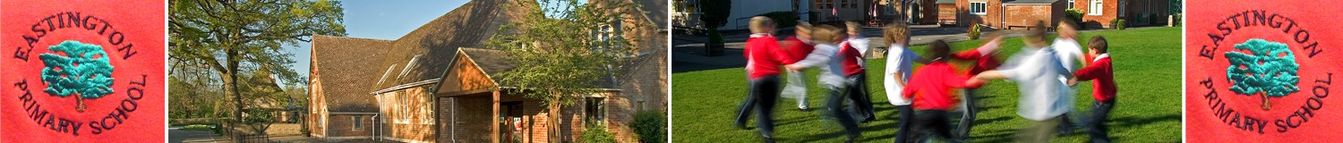

OCTOBER HALF TERM HOLIDAY FREE SCHOOL MEALS

Dear Parents, carers,

For the October half-term, Gloucestershire County Council is providing vouchers to parents who have signed up to their Holiday Free School Meals (FSM) scheme. These vouchers are provided by Gloucestershire County Council as part of its commitment to ‘no child goes hungry’. The vouchers are funded through COVID-19 grant funding they have received and is separate from that of the term time free school meals.

Parents who have signed up to the scheme will receive a voucher for £15 for each child who is eligible for FSM which will cover the half-term week.

Parents who have signed up previously do not need to re-register, they have already been included, but, parents who think they are eligible should sign up as soon as they can.

Applications for Holiday Free School Meal Vouchers for October Half Term is open from Monday 13 September until midday Friday 24 September. Vouchers will be sent out between Monday 27 of September and 30 of September. Vouchers are being sent out early due to Covid grant stipulations.

For more information and to sign up if you haven't already please visit the website: Holiday School Meal vouchers page on (https://www.gloucestershire.gov.uk/holiday-school-meal-vouchers/ ) on the GCC website. For any queries please contact: childrensfund@gloucestershire.gov.uk

With kind regards,

Zoe Avastu
Headteacher

