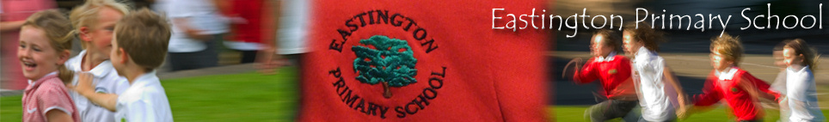

NEWSLETTER 1
13th September 2021
Dear parents and carers,
Welcome back. I hope you have had super family time in the holiday. I’ve spoken to many of the children and it sounds like they have enjoyed the locality, day trips and the beach.
We’re all looking forward to teaching your children and the teachers have been working hard to prepare for a positive year. We are delighted that the children can mix with their friends in other classes again – they have adapted to being in the playground together well already. They are fantastic!

Reception Children
What a wonderful start to school. The new Reception pupils are settling well under the guidance of Mrs Parsons and Mrs Williams. We are delighted that Ms Levan will be leading weekly Forest School sessions for the children in Reception too. We are looking forward to finding out the character of your child and working with them.
Thank you for making the transition to school smooth for your child by arriving on time and offering positive, encouraging words to your child when needed. Parting in the morning might be difficult (for you or your child) but children start smiling when they become engaged with their learning activities. Be reassured we will always contact you if we have a concern/your child continues to be unsettled.
Eastington has a strong and committed staff team and I know we will work together to ensure the best outcomes for your child.

Allergies
We have pupils on site who have a strong allergic reaction to nuts and shellfish. Please be aware and do not send products with shellfish or nuts (peanut butter, cereal bars with nuts etc) into school as part of your child’s lunch/snacks. Many thanks for your cooperation in this matter.

Reading and Spelling Information Evening
We will hold our Reading and Spelling Information Evening on the 21st September at 6pm-7pm for parents of children in Reception, Year 1 and Year 2.
This is a great opportunity to find out what we teach in each year group, how we teach reading and spelling and ways to work together with us to support your child in being the best reader and writer they can. I encourage all parents with children in Rec, Y1 and Y2 to come.
Parents of Reception children will meet in the main hall, Y1 parents will meet in Class 1 and Y2 parents will meet in Class 2. All rooms will be ventilated by an external door being open. Please wear masks when entering the site and until seated as the main gate area may be crowded. Please hand sanitise when entering the site too. Many thanks.

Sport and Well Being Leaders
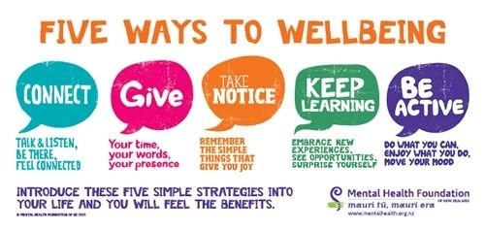
We are delighted to be starting our Sport and Well-Being Leaders training again this term. The present Y6 children will work with Miss Pates to develop their understanding and importance of the five ways of well-being. We are delighted that the inspirational Paralympian Andy Lewis will come to work with them and the school as part of this. The children will then plan and run activities at lunch times so they can support the other children in the school. An wonderful opportunity for all our Y6 children.

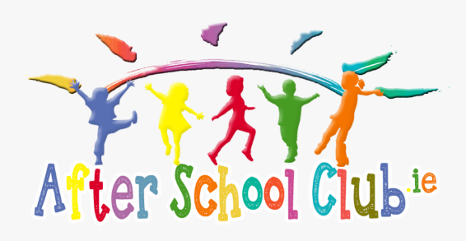
Clubs
We are really pleased clubs will begin again for Autumn Term – it is a special time for children to develop skills as well as have fun with their peers & teacher. You will have a letter regarding the club offer for this term so do talk with your children about the choices on offer. If your child wants to attend a club please complete the form and put it in the black post box outside the school office for Mrs Birch.
Thank you to the staff team for leading the clubs this term.

Assemblies
We are delighted to be holding daily assemblies face to face again!
Assemblies are a special time for the children, teachers and TAs. We explore our school values – these underpin all we do in school inside and outside the classroom and support developing a strong, positive character. Our values were developed with children and the children linked each value to an animal which they felt displayed that value.
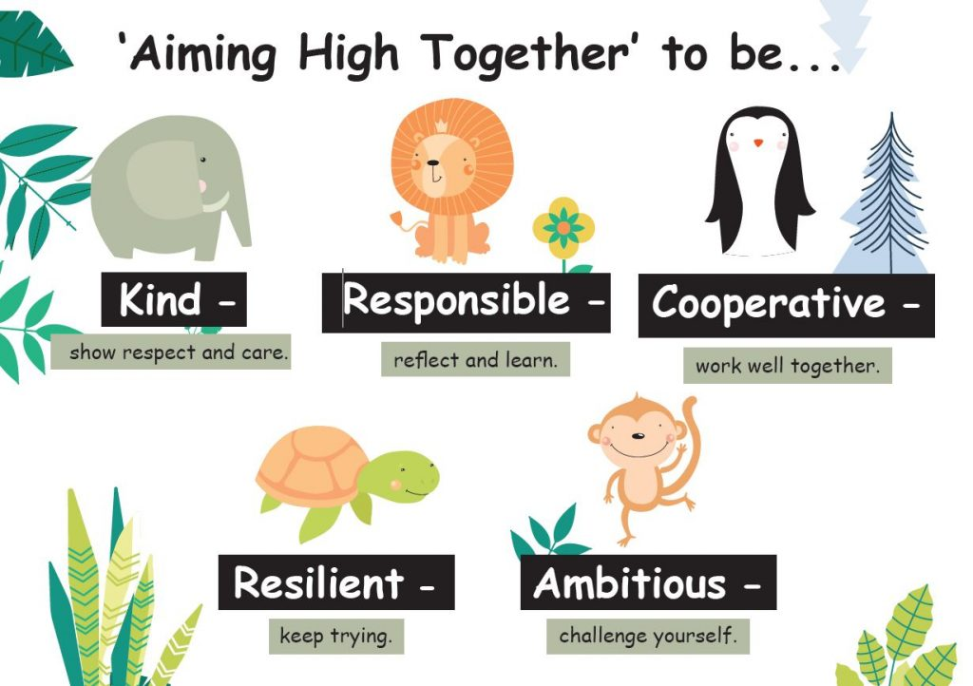

When together in assembly we learn from story characters, inspirational people and each other. We take time to stop and reflect - our approach is to ‘Look out, Look in, Look forward’. We also love singing together too!
Coming together in this way helps us to build a strong sense of community - we want every child to enjoy a sense of security & belonging to our school.
For the first three weeks of term we are exploring being kind. It has been wonderful hearing the thoughtful ideas of the children. Even more importantly, it has been brilliant to hear and see the children take action – I have heard lots of compliments and encouraging words and children including others in their games at playtimes. A cracking start to term.

Important secondary transfer information (YEAR 6 pupils)
A reminder that applications (Common Application Form) for secondary education, whether made electronically or on paper, must be made no later than the closing date of 31st October 2021. Further advice and support with this process is available from the Admissions and Transfer Team based at Shire Hall, Glos. (website: http://www.gloucestershire.gov.uk/schooladmissions).
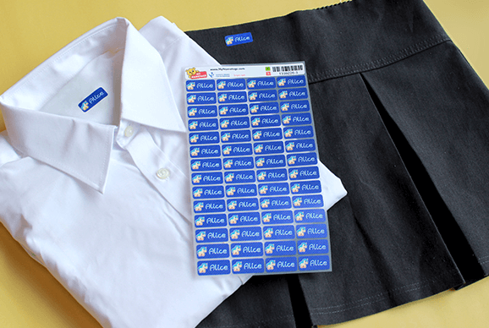
Naming of children’s belongings
A request from all staff: please can parents/carers name water bottles, snack tubs and jumpers clearly with your child’s name. We don’t want anyone to lose their kit or for children to lose learning time after break & lunchtimes searching for belongings. Items with names almost always return to the owner quickly. Many thanks for your help with this.

£1 Challenge
The PTA and the School Council worked together to set the children a challenge over the Summer holidays with the aim of supporting the entrepreneurial spirit within and raising funds for school. Lots of children took part and we will hear more about their wonderful achievements in our next newsletter.

