Special Educational Needs and Disabilities Policy

Date of Policy: September 2021
Date of Review: September 2022

This policy was written by the SENCo of Eastington Primary School with the SEN Governor in liaison with the SLT, all staff, and parents of pupils with SEND.

SENDCo: Miss Sarah Pates,
National Award for SEN Co-ordination.

Contact details: Eastington Primary School,
Churchend
Eastington
Stonehouse
Gloucestershire
GL10 3SB
E-mail: senco@eastington.gloucs.sch.uk

Compliance
This policy complies with the statutory requirement laid out in the SEND Code of Practice 0 – 25 (July 2014) and has been written with reference to the following guidance and documents:

- Equality Act 2010: advice for schools DfE Feb 2013
- SEND Code of Practice 0 – 25 (25 July 2014)
- Schools SEN Information Report Regulations (2014)
- Gloucestershire Guidance Booklet for Practitioners Working with Children and Young People Second Edition 2016

Aim
Eastington Primary School values the contribution that every child and young person can make and welcomes the diversity of culture, religion and intellectual style. The school seeks to raise the achievement, remove barriers to learning and increase physical and curricular access for all. All children and young people with SEND are valued, respected and equal members of the school.

As such, provision for children with SEND is a matter for the school as a whole. All teachers are teachers of children with SEND. The Governing Body, Head Teacher, SENCo and all other members of staff have important responsibilities.

Objectives

1. To identify and provide for pupils who have special educational needs and additional needs
2. To work within the guidance provided in the SEND Code of Practice, 2014
3. To operate a “whole pupil, whole school” approach to the management and provision of support for special educational needs
4. To provide a SENCo who will work with the SEND Policy
5. To provide support and advice for all staff working with special educational needs pupils

Identifying Special Educational Needs
A pupil has SEN where their learning difficulty or disability calls for special educational provision, namely provision different from or additional to that normally available to pupils of the same age.
At Eastington, we recognise the importance of early identification of SEND. Early intervention and response improves the long term outcomes for pupils. We assess each pupil’s current skills and levels of attainment on entry, building on information from previous settings and key stages where appropriate. At the same time, we consider evidence that a pupil may have a disability under the Equality Act 2010 and, if so, what reasonable adjustments may need to be made for them.

Class teachers, supported by the senior leadership team, make regular assessments of progress for all pupils. These identify pupils making less than expected progress given their age and individual circumstances. This can be characterised by progress which:

- is significantly slower than that of their peers starting from the same baseline
- fails to match or better the child’s previous rate of progress
- fails to close the attainment gap between the child and their peers
- widens the attainment gap

This can include progress in areas other than attainment – for instance where a pupil needs to make additional progress with wider development or social needs in order to make a successful transition to adult life.

The first response to such progress should be high quality teaching targeted at their areas of weakness. Where progress continues to be less than expected the class teacher, working with the SENCo, will assess whether the child has SEND.

Broad areas of need

Communication and interaction
Children and young people with speech, language and communication needs (SLCN) have difficulty in communicating with others. Children and young people with ASD, including Asperger’s Syndrome and Autism, are likely to have particular difficulties with social interaction.

Cognition and learning
Support for learning difficulties may be required when children and young people learn at a slower pace than their peers, even with appropriate differentiation.

Social, emotional and mental health difficulties
Children and young people may experience a wide range of social and emotional difficulties which manifest themselves in many ways. These may include becoming withdrawn or isolated, as well as displaying challenging, disruptive or disturbing behaviour. Other children may have disorders such as attention deficit disorder, attention deficit hyperactive disorder or attachment disorder.

Sensory and/or physical needs
Some children and young people require special educational provision because they have a disability which prevents or hinders them from making use of the educational facilities generally provided.

It should be noted that the following criteria are not SEN in their own right, but have an impact on progress and attainment:
- Disability (the Code of Practice outlines the ‘reasonable adjustment’ duty for all settings and school provided under current Disability Equality legislation – these alone do not constitute SEN)
- Attendance and Punctuality
- Health and Welfare
- EAL
- Being in receipt of Pupil Premium Grant
- Being a Looked After Child
- Being a child of Serviceman/woman

A Graduated Approach to SEND Support

At Eastington School we support Gloucestershire’s Graduated Pathway approach to both recording and monitoring progress of children and young people with SEN and/or Disabilities so that knowledge and understanding of what is working and not working to help a child is gathered and built upon. This information also helps to inform other agencies when additional input is required from them.

All teachers at Eastington Primary are responsible and accountable for the progress and development of the pupils in their class, including where pupils access support from teaching assistants or specialist staff.

The Code of Practice is clear in stressing that special educational provision is underpinned by high quality teaching. Personalised and differentiated approaches are available to all children at Eastington School and those with special educational needs will also benefit from these approaches. These are referred to as Universal approaches throughout the document. For some children these approaches will not be sufficient to meet their special educational needs and they will require more focussed and targeted support and intervention. These are referred to as Targeted approaches. Relatively few children will need a much higher level of support and intervention. These are referred to as Specialist approaches.

Provision at a Targeted or Specialist level for children who have been identified as having special educational needs should not be seen as a substitute for high quality teaching.

We follow the Assess, Plan, Do, Review cycle as described in the SEND Identification Flow Chart in Appendix 1.

Managing Pupils Needs on the SEND Register
See the SEN Monitoring Flow chart in Appendix 2

Criteria for Exiting the SEND Register
See the SEN Monitoring Flow chart in Appendix 2

Supporting Pupils and Families
In order to access information which can help parents and carers find and understand what services families can expect in Gloucestershire, please refer to the Gloucestershire Local offer which can be found at:
www.glosfamiliesdirectory.org.uk/kb5/gloucs/glosfamilies/localoffer.page

The school’s SEN Information Report can be found on the school website.

Admission arrangements – see Admissions Policy on the school website

For access to exams the relevant teacher, in conjunction with the SENCo, follow current guidelines from the appropriate exam bodies.

Transition meetings are held at the end of each academic year within the school.

The school has established and will maintain links with the secondary schools in the area with the Year 6 teacher meeting with the respective Year 7 teachers to discuss and facilitate children’s smooth transition.

The Foundation Stage staff and the SENCo work closely with staff at the feeder pre-schools to ensure that, should it be required, provision for additional needs are set in place ready for any child to start school.

When a child joins Eastington from another primary school the school office will request transfer details for that child. Any child who is already on the Code of Practice will continue to be supported in accordance with the previous school’s advice until such time as this can be reviewed. When appropriate, the class teacher and/or the SENCo will make contact with the child’s previous school in order to meet the child’s needs.

Supporting Pupils at School with Medical Conditions

The school recognises that pupils at school with medical conditions should be properly supported so that they have full access to education, including school trips and physical education. Some children with medical conditions may be disabled and where this is the case the school will comply with its duties under the Equality Act 2010.

Some may also have special educational needs (SEN) and may have a statement, or Education, Health and Care (EHC) plan which brings together health and social care needs, as well as their special educational provision and the SEND Code of Practice (2014) is followed.

In Eastington School pupils with medical needs have a Health Care Plan which is kept in the School Office.

Monitoring and Evaluation of SEND
Please refer to Appendix 2 – SEND Monitoring Flow Chart

Training and Resources

At present the way SEN Funding is determined is agreed locally, through Schools’ Forum and is given to schools under three main headings:
Element 1 – Core Funding
Element 2 – Additional Support Funding
Element 3 – Top Up Funding
We are moving towards an anticipated national funding formula, further information regarding this can be found on the Government website https://www.gov.uk

The SENCo attends local cluster meetings and training courses where appropriate. The school has a programme for all staff, which includes the identification of training needs. Staff attend training organised by the LA and other external agencies such as partnership groups.

Roles and Responsibilities

SEND Governor
The SEN Governor will inform the Governing Body on all aspects of SEND in the school to ensure that SEN work is valued and well supported in the school. SEN Governors will need to carry out these responsibilities in a number of ways:
- informing themselves about SEND systems and practices in school through meetings and school visits
- ensuring that the progress of learners with SEND is closely monitored through reviewing and understanding internal and external data
- understanding how the notional (delegated) SEND budget is used and ensuring that wider financial decisions do not adversely impact on the support for pupils with SEND
- understanding the national and local context of SEND support
- using their school visits to inform themselves about the work the SENCo is leading
- ensuring that the views of pupils and parent/carers in relation to the SEND provision that is being made, are sought
- building a trusting and supportive relationship with their SENCo
- putting together an annual report on SEND with input from SENCo and Governing Body Committee (if relevant) which is published on the website and updated annually.

SENDCo

The SENCo works closely with the Head Teacher and all other staff and is involved in the strategic development of SEND policy and provision. The SENCo has responsibility for the day-to-day operation of the school’s SEND policy and for co-ordinating provision for pupils on the SEND register, in order to raise the achievement of children with SEND.

Key responsibilities are:

- contributing to the strategic development of SEND provision;
- overseeing the day to day operation (and periodic review) of the school’s SEND policy;
- coordinating, tracking progress and evaluating the impact of the provision being made for pupils with SEND;
- ensuring the full inclusion of SEND pupils within in the school community and access to the school’s curriculum, facilities and extra-curricular activities;
- liaising with and advising other teachers the effective deployment and performance management of learning support staff
- maintaining detailed records of the provision made for children and young people with SEND
- liaising with parents and carers
- contributing to the professional development of staff
- liaising with external agencies
- deploying the SEND budget and reporting on how it is spent
- reporting on the progress of children and young people with SEND

Teaching Assistants

The designated SEN TA time is managed by the Class Teachers in conjunction with the Head Teacher and SENCo. TAs and the SENCo, together with Class Teachers, provide support for children with SEN across the school. TAs maintain records of the children they work with, in accordance with the school procedures, and attend reviews and meetings as requested.

Designated Member of Staff with specific Safeguarding Responsibility
Mrs Parsons (DLS), Ms Avastu (DDSL) Miss Pates (SENDCo) and Mrs Redpath (Deputy).

Member of Staff responsible for managing funding for Pupil Premium Grants and Looked After Children
Head Teacher and SENDCo

Member of Staff responsible for managing meeting medical needs of pupils
Head Teacher

Storing and Managing Information
SEND information is stored securely on site and electronically and is shared with relevant stakeholders when appropriate. Some information relating to children’s needs is stored in the Inclusion files, kept securely in the classroom.

Review the policy
This Policy will be reviewed annually.

Accessibility
The school’s equality scheme can be found on the school website.

Dealing with complaints
The school follows the procedures set out in the Complaints Policy which can be found on the school website.

Bullying
Please see the school Behaviour Policy on the school website

Appendices

Appendix 1 – SEND Identification Flow Chart/Initial report on needs and concerns

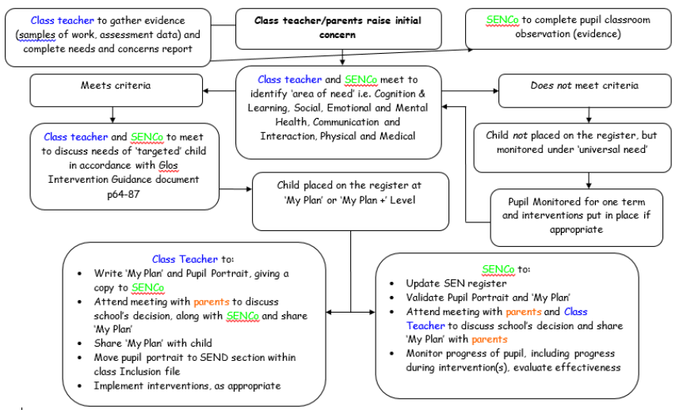

Appendix 2 – SEND Monitoring Flow Chart
