PGL

7th May 2021
Dear parents of Year 6,

We are planning to run the Y6 PGL activity break at PGL Swindon. We have staff who are willing and available supervise our Y6 children while away: Mrs Redpath and Mrs Yorke.

Due to our present PGL date clashing with secondary transition days in local schools we are pleased to have changed the date of PGL to the w/c 28.6.2021. Mrs Birch will contact you soon regarding the costs of the trip and how to pay.

We will hold a PGL Information Evening for Y6 children & parents, where we will share/collect practical information needed for the visit-please do attend. This meeting will be on Tuesday May 25th 6-7pm and led by Mrs Redpath and Mrs Yorke – both have led visits to PGL before. The meeting will be held in the school hall so please enter and leave the school via the black gates. We will ventilate the hall and space chairs in line with guidance. Hand sanitiser will be available for you to use as you enter the hall area. Please wear masks, socially distance from others and avoid congregating in groups when on/around the school site. Many thanks.

Please be aware that if a child develops covid symptoms while at PGL parents would be called to pick them up. It will be important that someone in your household bubble is available to pick your child up through-out their PGL stay.

We do understand that there may be some uncertainty or nervousness, amongst both parents and children. PGL have assured us that they have been working hard to ensure the children get that same great PGL experience within a COVID-Safe environment. They have explained that the PGL Safety and Standards team have developed COVID-Safe practices which are implemented across all of our centres.

From the information we’ve read, we understand our children will be separated from children in other schools/bubbles. If you are interested, please see a summary of PGL control measures from their website below:

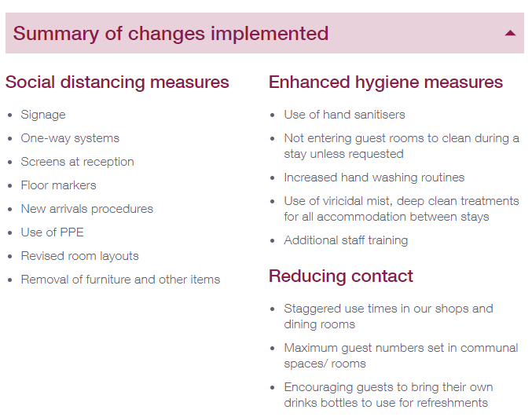

If you are interested, please find out more about their safety measures, and ‘PGL covid-secure policy and procedures’ here: https://www.pgl.co.uk/Files/DocumentManagerDocuments/Web/Policies/PGL-COVID-Secure-Policy-and-Procedures.pdf

Frequently asked questions on practical safety matters can be found here: https://www.pgl.co.uk/Files/DocumentManagerDocuments/Web/PGL-COVID-19-Health-and-Safety-FAQs-Summer-Term-2021.pdf

With kind regards,

Zoe Avastu
Headteacher

