

Eastington Primary School
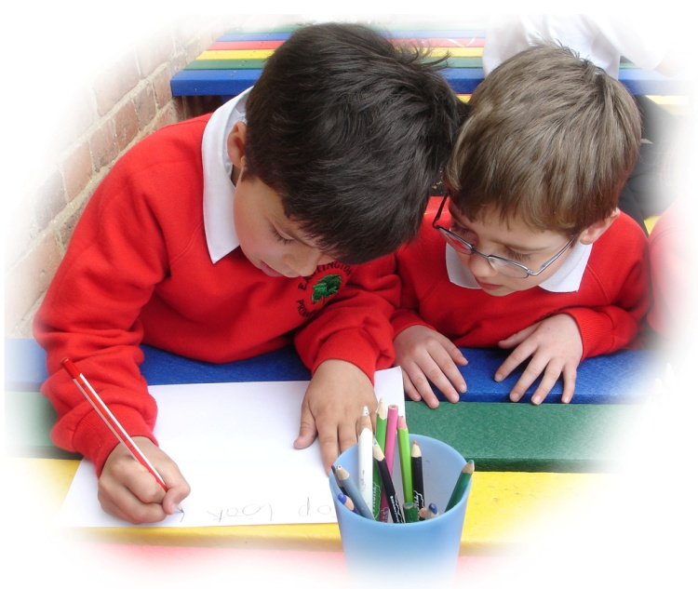

Starting School in Reception
September 2021

Information for Parents

Introduction

This booklet is designed to answer many of the queries you may have about your child’s entry to school in September.

We hope to make the transition from home and pre-school to school as smooth as possible for both parents and child.

Should you have any further queries/concerns then please do not hesitate to contact your child’s class teacher to discuss these further.

Our aim and values
Our aim is to educate the whole child in preparation for their future. We aim to present a broad, balanced and relevant curriculum that meets individual needs. We will always work towards children becoming independent in their learning, able to apply themselves confidently to tasks, to love learning and develop as a whole person.

We have high expectations of all children who come to our school - our full behaviour policy is on our website. Our school values underpin how we expect children to behave as well as learn. Our core values underpin all we do at Eastington:

Aiming high together to be:
- Kind – show respect and care
- Ambitious – challenge yourself
- Cooperative – work well together
- Resilient – keep trying
- Responsible – reflect and learn

Transition
The first few weeks of your child’s school life in September are VERY important, and for this reason your child will begin on a part time basis, attending morning or afternoon sessions. You will be sent a timetable explaining this. Time spent in school will gradually increase over three weeks and full time education will commence at the start of week four.

Your child will still be very young and has many new routines to learn at school, so a gradual start will be particularly beneficial for them. It will also allow the staff to spend time with and get to know the children on a more individual basis. During this time we will carry out some assessments as we talk and play with your child.

School Hours
Due to Covid 19, we are operating differently in many ways such as staggered drop off/pick-up times at different gates, staggered lunch and break times etc..

Drop off time for children in Class One is anytime between 8.50 and 9.ooam at the wooden gate-please do not be early or late as we are working hard to avoid children in different classes mixing – in line with school guidance.
The class TA will be at the wooden gate to greet the children and the class teacher will be in the room to welcome them and explain where to put their bags etc.

Pick up time for children in Class one is 3.15pm at the wooden gate.
At the end of the school day the children will be brought to the wooden gate by their teacher/TA. When you a parent/carer is seen at the front of the queue the teacher/TA will call their child to be collected.

Please let your child and teacher know if someone else will be collecting him/her from school or if you are going to be late. Please phone Mrs Birch in the school office – 01453 822922. This will save possible distress and confusion. We cannot let a child go home with another adult, even if known, unless we have prior notification.

We ask children do not play running games/scoot/ride bikes in the playground/school front before/after school as we have parents with younger children/babies who might get hurt.

Attendance
Attendance is strong in our school. Parents are expected to use term breaks for family holidays to maintain consistency in their child’s education. We ask that dentist appointments are made in holiday time wherever possible for the same reason. We appreciate that it is sometimes necessary to withdraw your child during the working term in exceptional circumstances such as attendance at a funeral. A request for absence form is available from the school office for this purpose.
If your child is absent due to illness, please contact Mrs Birch in the school office as soon as possible on the day so we know your child is safe.

Lunchtime and Break time
We encourage the children to eat a healthy diet and operate a healthy snack policy at break time. The children in Rec and KS1 can choose from the fruit and vegetables that we have in school or bring their own piece of fruit from home. If a child prefers they could have a piece of cheese or a few crackers as an alternative. Please avoid crisps, chocolate and other sugary foods.

The children are also encouraged to have a drink at regular times of the day so please send in a named water bottle each day.

For lunch, children can choose between a hot school lunch or bring in a packed lunch from home. Hot school meal menus will be sent to you so you can help your child choose – when they come into school they will tell their teacher what they want during registration. Children in Reception, Year 1 and 2, children are eligible for Infant Free School Meals which means they can have a hot school lunch without payment.
If your child brings sandwiches their lunch box will be checked by a member of staff before they leave the hall and if your child is particularly unsettled and not eating then we will let you know. Please label your child’s lunch box and drink.
Children will eat in the hall so they can eat/talk with friends.
Please inform us of any allergies or special diets if you have not already done so. Caterlink, the LA provider for school lunches, will need this information too so they can adjust their menu – they will request a note from the doctor regarding allergies so please consider getting this organised now if you want to access hot lunches.

Uniform
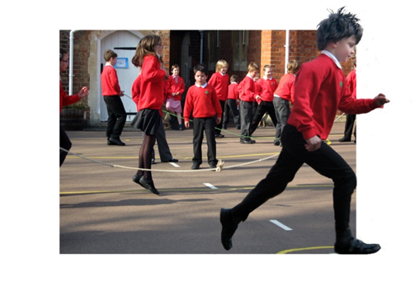
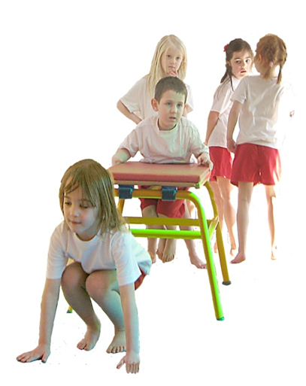
At Eastington we are really proud of our uniform – it is one of the ways we show we are a community that belong together. It should also make dressing in the morning an easier event for children and parents.

The uniform includes flat school shoes (not trainers/heals/open toed sandals) and no jewellery (other than stud earrings) or nail varnish.

At the start of Reception, children will need:
- White polo shirts or white shirts
- Grey or black trousers or skirts/dresses
- Red jumpers or cardigans
- PE/kit bag containing a white T-shirt, red shorts and daps/pumps
- Book bag
- Coat

Uniform can be purchased from Bateman’s in Stroud – it is here you can buy uniform with our school logo on. There are many other retail outlets that sell our uniform without our school logo too.
Daps, all PE kit items, jumpers and coats must all be named. It makes reuniting a child with a lost item easy.

Big friends, Little friends
We operate a ‘buddy’ system with the older children in Class 5 whereby your child will be given a ‘Big friend’ who will look out for them at playtimes, share reading times and special events. We spend time getting to know your child and then pair them with the children in Class 5. Your child will then meet and get to know their ‘big friend’ and they will introduce themselves to you too. Being a ‘Big friend’ is seen as an honour and privilege in our school and your child will develop a special relationship with their buddy over time.
We will return to our Big Friends, Little Friends buddy system as soon as Covid restrictions allow.

Preparing your child for school
We recognise children are different and will be at different stages of development. We will liaise with all our pre-school feeders to gain relevant information to support the transition to school.
There are some key skills that will support your child. It would be helpful if your child were able to do some of the following when they started school:
- Dress and undress himself/herself.
- Pack and unpack his/her bag.
- Hang his/her belongings on his/her peg.
- Use the toilet properly and know how to wash and dry their hands.
- Use a tissue and wash hands after.
- Be responsible for tidying and putting away his/her toys and equipment.
- Play amicably with and share with other children.
- Listen and make eye contact when being spoken to.
- Draw freely with crayons/pencils
- Know how to sit quietly and listen to a story being told or read.
- Recognise and name colours.
- Complete simple jigsaws.
- Recognise their name.
- Be encouraged to tell an adult when something is wrong or has upset them.

Developing pre-writing and pre-reading skills
- Always have paper and pencils readily available for your child to draw, write, or scribble on. This need not be too expensive, keep your old cereal boxes, envelopes, birthday/Christmas cards etc. You could start with rhythmic patterns, which will help your child’s movement and pencil control.
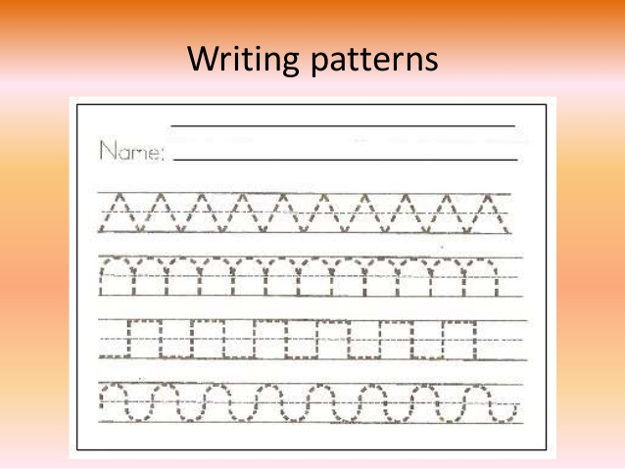

e.g.

- Play ‘I spy’ to relate letter sounds with words. It really doesn’t matter if your child thinks ‘s’ is for both ‘settee’ and ‘ceiling’ as long as they are making the sound relationship.

- With your child’s favourite books, leave spaces for him/her to fill in the missing words. You might also point to the words as you read them.

- Sing nursery rhymes/songs and play action games with your child and encourage him/her to join in with you.

- Read to your child every day for enjoyment and as a way of spending good time together as well as learning new vocabulary. We all want children to see books as being a source of pleasure.

With all the aforementioned activities, forcing your child before he/she is ready or when in an uncooperative mood will probably do more harm than good. Try and tackle them in a fun way but stop when your child has had enough. A child’s concentration at this stage can still be short.

Writing
Some children are keen and ready to learn to write before coming to school. This is great but please encourage your child to form his/her letters correctly and write in lower case not in capitals (please see below). Tracing letters helps with pencil control and formation. You could perhaps write in yellow felt tip pen for your child to trace over the top and mark with a dot to show them where to begin.

We teach the children to hold their pencil with the correct grip through different exercises and practise.
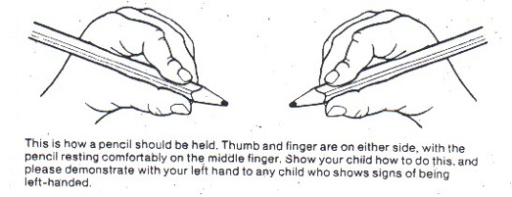

Please refer to letters phonetically - that is the sound which they make and not letter names ‘ay, bee, cee, dee’. This will help your child to learn to read and write.
To help the children learn their letter sounds they will be introduced to and learn actions that accompany the letter sounds through the ‘Jolly Phonics’ approach. We will hold an evening in the Autumn term to explain our phonics programme and how we teach phonics at Eastington - the more we work together in this crucial area the better for your child – please do attend.

Please see below to see how we form our letters in school.

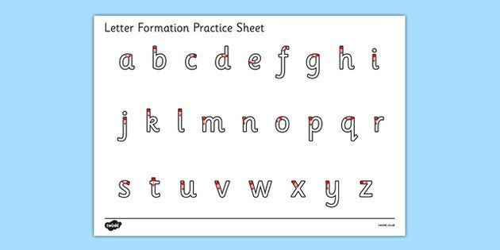

Number work
When you are sharing books with your child count things in the pictures sometimes with him/her. Count trees, steps etc when walking too. Ask your child to get you four plates out for dinner and four knives and forks to go with them – there are many opportunities for counting. Count backwards tooif your child enjoys number - count as you put the forks away after drying up: 4,3,2,1,0.

Sing and play number rhymes, which will help your child become familiar with numerical order, eg ‘1, 2, 3, 4, 5, Once I caught a fish alive …’

This is how we form our numbers:

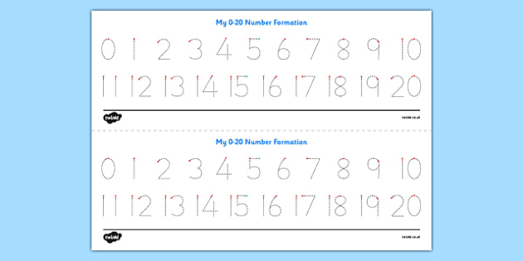

Please find a link below to a GCC webpage that contains much useful information for children transitioning to school too. https://www.gloucestershire.gov.uk/education-and-learning/getting-ready-for-school We hope some of the links prove useful for you.

The most precious gift you can give to your child both now and throughout his/her schooling is your time, interest and support. The child who receives the support from home will enjoy getting the best from school. We believe education to be a partnership between home and school and we will do our best to further the education you have already begun and help your child realise their potential.

We are really looking forward to working with you and hope you have a great summer.

