Eastington Primary School

Remote Learning Policy

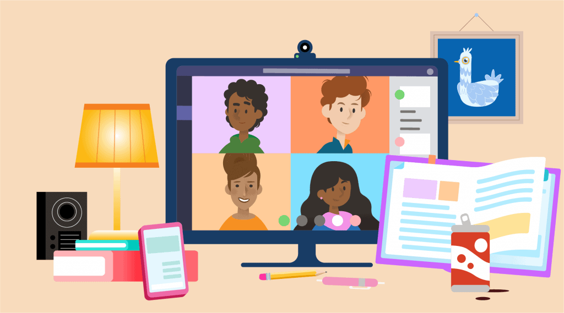

December 2020

This policy is a working document. We have been ambitious and tried to provide a full days teaching, following our present planned curriculum as much as possible, supporting different abilities & offering feedback. If/when we move to remote learning adaptations may be made to ensure learning is as effective as possible within the capacity we have. No staff member is an expert or experienced in remote learning though all have had training on Google Classroom and Zoom. If we switch to remote learning we know there will be teething problems and for us and parents. We will work hard together to resolve these. We are fortunate to have a few parents who are very skilled in computing who are willing to support parents via e-mail practically too.

Contents
- Aims
- Roles and responsibilities
- Who to contact
- Data protection
- Safeguarding
- Monitoring arrangements
- Links with other policies

1. Aims
This remote learning policy aims to:
- Ensure consistency in the approach to remote learning for pupils who are learning at home
- Set out expectations for all members of the school community with regards to remote learning
- Ensure pupils unable to attend school remain engaged and included within the school community.
- Continue to ensure that every child receives the best education the school can provide them while remote learning.
- Ensure that remote education follows the school curriculum, as much as possible, allowing for learning journeys to be consistent as children work at home and then return to school (whether from full lockdown, class self-isolation due to a case of covid in a class bubble.)
- Provide appropriate guidelines for data protection

2. Roles and responsibilities
- Senior leaders
Alongside any teaching responsibilities, senior leaders are responsible for:
• Co-ordinating the remote learning approach across the school (undertaking survey of provision needs/internet access, ensuring remote learning meets guidance needs, staff training, hardware/software procurement to support learning etc)
• Monitoring the effectiveness of remote learning and adapting provision within school capacity.
• Monitoring the security of remote learning systems, including data protection and safeguarding considerations.

- Designated Safeguard Leader (DSL)
The Designated Safeguard Leader (DSL) is responsible for Safeguarding concerns, including those related to Remote Learning. Please also refer to Child Protection and Safeguarding Policy.
The DSL is Mrs Parsons and the Deputy DSL are Ms Avastu, Miss Pates and Miss Child.

- Teachers
Setting work –
• Teachers will upload a daily plan to the school’s virtual learning platform (the school website or google classroom). The daily plan, learning activities as well as zoom session times and details will be uploaded by 6pm the previous day – please note this may not be possible if a class has to self-isolate in the middle of a working day.
• Teachers will provide learning for their current class.
The work they will aim to provide is daily mathematics/mental maths, writing, SPAG (including phonics) reading and PE lessons. Teachers will also aim to provide a daily foundation subject lesson alongside allocating time for children to read for pleasure.
• Teachers will use resources provide by the Oak National Academy, White Rose Maths and BBC Bitesize, as well as other resources identified by school curriculum leaders/government guidance to support remote learning.
• Teachers will lead 1-3 Zoom sessions a day. Children will be invited to at least one Zoom session a day to enable the child to connect with others. These will be 20 minutes long. The Zoom sessions will usually be linked to writing or core subjects but may be for any subject. Zoom sessions may be for the whole class or a group of children. These sessions will allow children to access teaching by those who know them as well as interact with their teacher and peers.
Zoom sessions have been timetabled carefully to prevent overlap so families with children in different classes will be able to attend.

Providing feedback on work -
If using the school website to provide feedback:
- Teachers will aim to provide answers for all lessons, this will include foundation subjects where appropriate.
- Children will self-mark their work and then return it to teachers if they found an aspect particularly challenging or easy – this will support the teacher in adapting work set for the next day/the focus of a Zoom session.
- The teacher will provide written feedback for at least one subject each day via e-mail – it is the teacher’s responsibility to let the children know which subject they will provide written feedback for each day – this will be included in their daily timetable. The feedback could consist of positive feedback and something to move learning forward. Teachers will usually provide feedback for writing task the most often, but this may vary.
- If there are misconceptions or the child has not understood, teachers may adapt learning for the next day or the content of a Zoom session. They will aim to reply via email to help clarify and where necessary set an additional mini task/question to support children’s individual learning.

If using the google classroom to administer work:
- Teachers will aim to provide answers for all lessons, this will include foundation subjects where appropriate. Children will self-mark their work and then return it to teachers using google classroom.
- Pupils should submit all their work to their class teachers including what has been self-marked. If the child has understood, teachers will aim to provide pupils with an acknowledgement of this. If there are misconceptions or the child has not understood, teachers will aim to reply directly to the work submitted to help clarify understanding and where necessary set an additional question/mini-task to support children’s individual learning. (We do not know if this will be manageable as we are not experienced in remote learning but it is our ambition.)
- Teachers will aim to give more detailed feedback to the child based on their work submitted at least once a day. The feedback could consist of positive feedback and something to move learning forward and this will be sent directly back to the child attached to their work. Teachers will usually provide feedback for writing task the most often, but this may vary. (We do not know if this will be manageable as we are not experienced in remote learning but it is our ambition.)

Communication and Attendance
– Teachers will aim to communicate/engage with each child in their class each day. This could be through: a zoom lesson, written feedback to work or an email/message regarding their work.
-Emails or messages received from parents and pupils are to be checked between 9am and 3.30pm, Mon- Fri. Teachers will aim to respond to parent question/query by emails within 48 hours wherever possible.
-If a child is sick and so not able to engage in remote learning parents should contact the school office in the usual way. We will pass this information onto teachers so they understand why a pupil might not be engaging in remote learning. We expect we will need to continue to make daily returns of attendance to DfE so we need to be able to share accurate information.
-Teachers will keep an attendance register of engagement as required by DfE. Teachers may e-mail & phone parents if children do not engage in learning to offer support.
-Families with children in a vulnerable group who are not attending school on site will be called weekly. This will continue to be undertaken by the SENCO/DSL.

Pupils with SEN
When using the website, children with my plans and EHCPs will receive work that meets their needs. This will be emailed to parents. Teachers will use a range of groupings for zoom sessions which may include specific groups to support pupils with SEND/different abilities.
When using google classroom, work will be assigned using google classroom, rather than emailed to parents. Teachers will use a range of groupings for zoom sessions which may include specific groups to support pupils with SEND/different abilities.

- Teaching Assistants
In the event of a local or national lockdown where pupils are asked to be at home to support reducing risk, teaching assistants will support learning for vulnerable & critical worker children on site. Gaps in this provision will be filled by the HT in the first instance.
In the event of a class self-isolation, teaching assistants in that class bubble will need to self-isolate.
In the event of a teacher self-isolating, teaching assistants may be redeployed to support another class of children working on site while their teacher provides work/teaches on zoom.

- Subject leads
In the case of a full lockdown (over two weeks), alongside their teaching responsibilities, subject leads are responsible for monitoring the work teachers set for their subject. (However, if time is an challenge or staff are asked to work from home, teaching their class well remotely will be their main priority.)
Subject Leaders will offer support to teachers where needed.

- Parents and pupils
Staff can expect pupils learning remotely to:
- Engage daily and be contactable during the school day – 9am-3.15pm
- Join in class Zoom sessions. When working on Zoom follow the school values of being kind, cooperative and responsible.
- Be responsible for working hard. Complete work set by your teacher to the best of your ability in the time given.
- Seek help/share if you find something hard so your teacher can help. Teachers can contact you/your parents by e-mail, phone, Google Classroom.
- If using school loaned technology, only use this for school learning.

Staff can expect parents with children learning remotely to:
– Make the school aware if their child is sick and so not able to participate in remote learning in the usual way by contacting the office on 01453 822922 before 9am. We will inform the class teacher.
– Seek help from the school if they need it. Teachers/SENCo will help with learning needs. We have a small number of laptops ready for home use and several skilled & willing parents who can help with setting up computing issues via phone/e-mail.
– Support their child as much as possible (we understand this will be dependent on the age of the child/parent work commitments)

- IT Technician
The IT technician is responsible for:
- ensuring computers that are loaned to families, if needed, are working and cleaned of content.
- Bitlocker is turned on staff laptops
- Anti-virus/antispyware software is up to date or to support staff in undertaking updates when needed.
- Keeping operating systems up to date on staff laptops or support staff in undertaking updates when needed.

The IT technician is Mr Kerry Sawyer.

- Governing board
The governing board is responsible for:
– Monitoring the school’s approach to providing remote learning to ensure education is provided at home when needed
– Ensuring that remote learning systems are appropriately secure, for both data protection and safeguarding reasons

3. Who to contact
If staff have any questions about remote learning, they should contact the following individuals:
– Issues in setting work, online behaviour, their well-being, data protection: talk to the HT, Deputy HT, SENCo & Inclusion Officer
– Concerns about safeguarding: talk to the DSL
– Concerns regarding pupils with SEND: talk with the SENCo & Inclusion Officer
-Concerns with IT: talk to Deputy HT or IT technician

4. Data protection
4.1 Accessing personal data
When accessing personal data and providing for remote learning purposes, all staff members will:
- Use school laptops and school encrypted & password protected portable hard drives
- Continue to use 365 Sharepoint to store/retrieve shared documents – access is limited dependent on user level
- Hold Staff Meeting by 365 Teams when needed
- Continue to use only school e-mails when communicating on school matters.
- Continue to use Switch Egress e-mail when communicating on safeguarding matters.
- Use school laptops and iPads to access remote learning provided by teachers when children are on site

4.2 Processing personal data
Staff members may need to collect and/or share personal data such as phone numbers or email addresses as part of the remote learning system, this will be sent to staff using their egress email. (Egress is provide e-mail security to prevent accidental/intentional breaches and protect sensitive information).
Staff are reminded to collect and/or share as little personal data as possible online.
Staff will delete the information when no longer needed for remote learning (shredding for hard copies/deleting computer files)

4.3 Keeping devices secure
All staff members will take appropriate steps to ensure their devices remain secure. This includes, but is not limited to:
- Use their school laptop for remote learning work.
- Not working in a public space, such as a park/café, when providing remote learning/planning etc
- Keeping the laptop/hard drive password-protected – strong passwords are at least 8 characters, with a combination of upper and lower-case letters, numbers and special characters (e.g. asterisk or currency symbol)
- Keeping the bit locker on so data on the device being used will be encrypted-discuss with our IT technician.
- Shutting/closing laptops when not in use and making sure the laptop being used locks if left inactive for a period of time.
- Not sharing their school laptop with family or friends to use.
- Ensuring antivirus and anti-spyware software is up to date.
- Keeping operating systems up to date – always install the latest updates – discuss with our IT technician if you have questions/concerns.

5. Safeguarding
Please refer to Child Protection and Safeguarding Policy.
If you wish to talk with a DSL you can call the school office on 01453 822922 and you will be contacted by the DSL or one of the Deputy DSL. The DSL is Mrs Parsons and the Deputy DSL are Ms Avastu, Miss Pates and Miss Child.
There will always be a DSL/a Dept DSL on the school site/contactable, even if we are in full lockdown when only children in specified critical worker/vulnerable groups are working on site.
There will always be a first aider on site, even if we are in full lockdown and only children in specified critical worker/vulnerable groups are working on site.

6. Monitoring arrangements
This policy will be reviewed as and when updates to remote learning are provided by the government and in light of practical issues raised when starting to undertake remote learning.

7. Links with other policies
This policy is linked to our:
- Attendance Policy and Attendance Addendum
- Behaviour policy and Behaviour Addendum
- Child protection policy and coronavirus annex to our child protection policy
- E-safety and internet acceptable use policy

