Welcome Back to School
6.1.2021
Dear parents,
It was brilliant to have your children with us this today. It has been a very busy and positive day on site. The children have settled in well to their hubs. It is great they have the opportunity to be together as well as learn. The technology and internet has behaved on the whole. For me it has been wonderful to hear their playful noise from the office – how a school should sound!
Thank you for distancing so well when dropping off this morning. Thank you for dropping off on time too – I’m sure that wasn’t easy with the ongoing road works on Spring Hill. Do feel free to drop off anytime between 8.40-8.50. After this we will lock the gates as usual so the site is safer.
The children have discussed the new routines & timetable for their hub. They have also looked again at the importance of handwashing, etc. The children have been a fantastic, as always, at picking up new ways of working, being responsible for their learning and being kind – you should all be very proud parents.
Look forward to seeing everyone again tomorrow,
Zoe Avastu
Headteacher

Enjoy a few photos of the day…
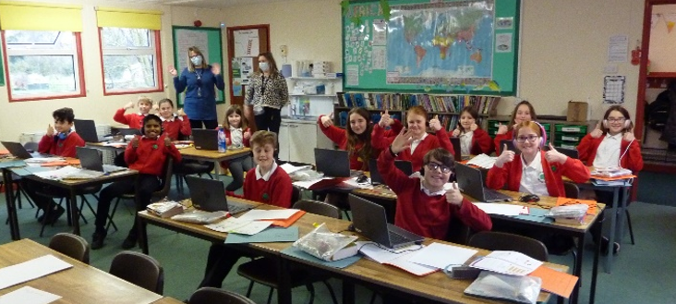

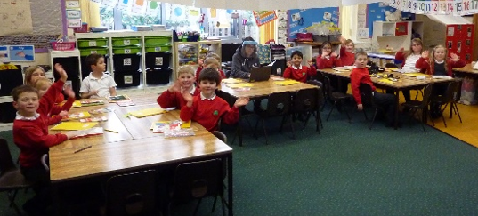
A positive start for children on site.
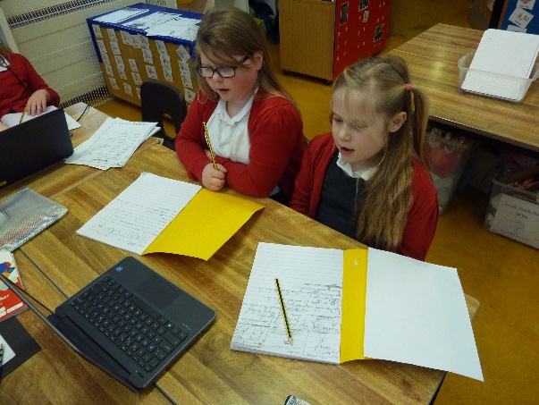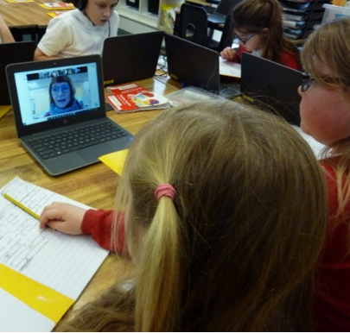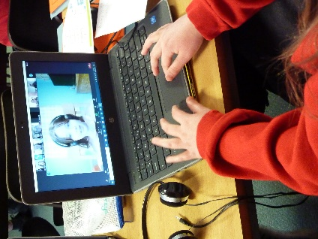
It was good to learn with our teachers and see our friends on Zoom.
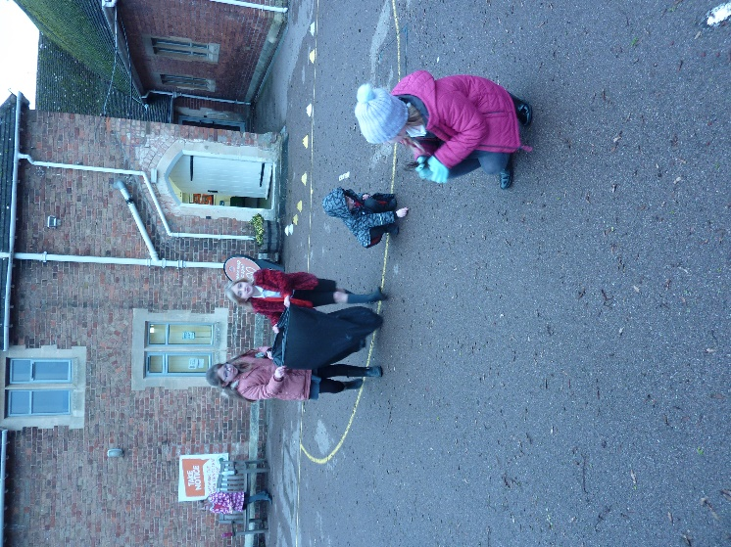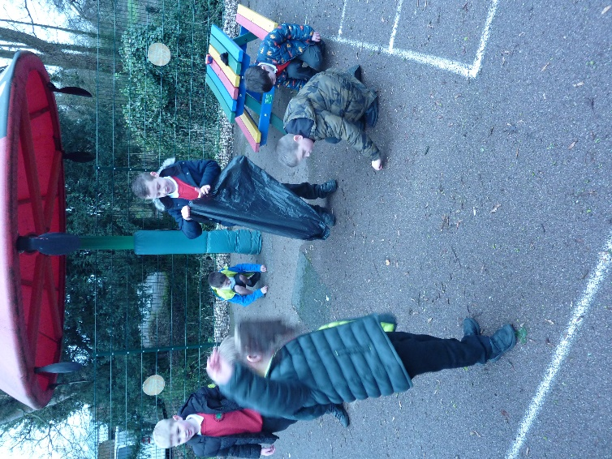
Lots of the children in the younger hub helped to clear the playground of twigs and leaves so they could play safely. Max was impressed by the giant leaf he found.

