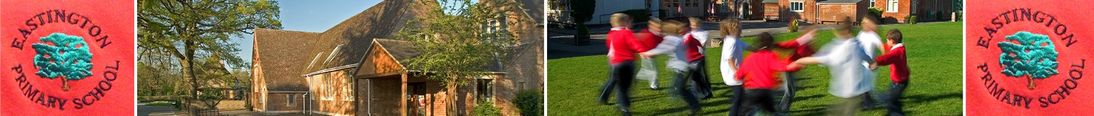
Food allergies at school
2.9.2020
Dear parents and carers,
We know children can have difficulties with specific foods. This year we have two pupils in our school who have serious food allergies to peanuts, seseme/shell fish. Because of the seriousness of these allergies, we are asking you to refrain from sending in peanut, sesame and shellfish products into school for lunch/break snacks.
Our aim is to make our school a safe place for all our children. We appreciate your cooperation and understanding in this matter. Please do contact us if you have any questions. To find out more about food allergies please see: https://www.nhs.uk/conditions/food-allergy/
With many thanks for your help,

Zoe Avastu

