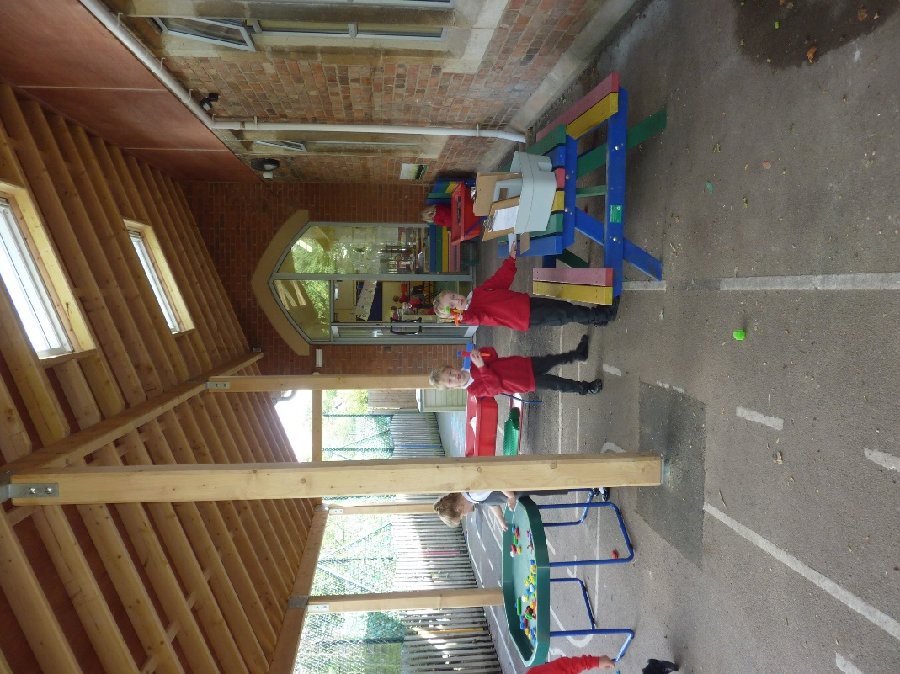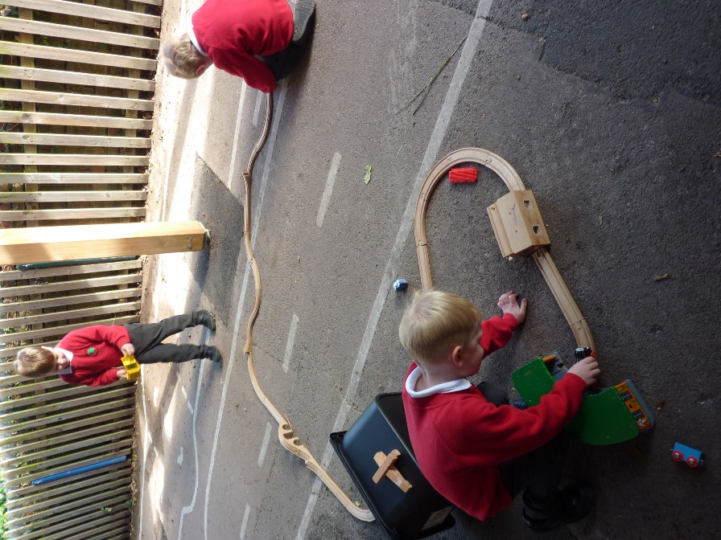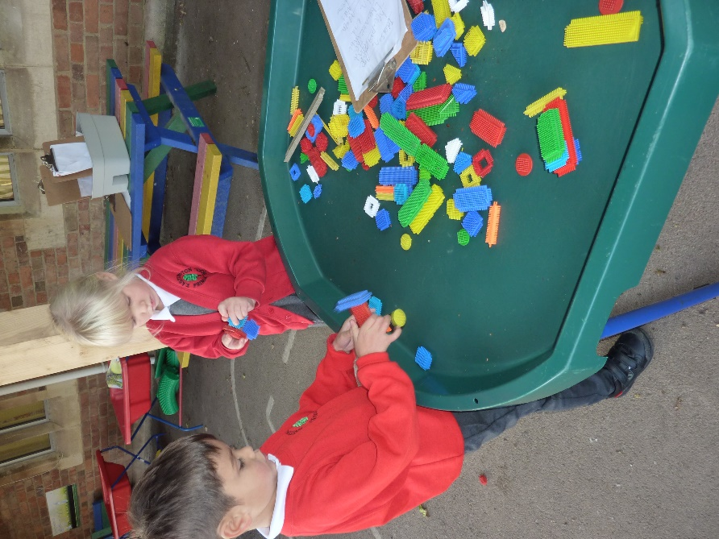

**New Play Area Cover**

11.10.2020

Dear parents/carers,

As you know we have been on a journey to put in place a larger covered area for our Reception and KS1 children to use.

We are delighted that it is now up and in use. The children are thrilled to be learning outside and as we move into the wetter weather it will in valuable in sustaining this.

We hope to have the floor area re-tarmacked and the wood stained over the next holiday to complete the work.

I would like to take the opportunity to give my sincere thanks to Mr Michella and the Keitone team for all their hard work and perseverance with the project. It is already making a real difference to the children in our school.

With kind regards,

Zoe Avastu