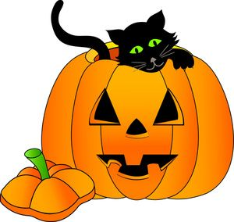

**Happy Halloween**

20.10.2020

Dear parents /carers,

Unfortunately the PA Halloween Disco has not been able to go ahead this year. However, our wonder PA have organised Halloween treat bags for the last day of term. The bags are stuffed full of sugary goodies and for will cost £1.

If you want your child to have a Halloween treat bag they can bring in £1 on Thursday. They can buy their treat bag in their classroom.

Covid safety—the Halloween treat bags will have been untouched for 48 hours before sale. Staff will not handle the money or the bags - money will be collected in a tub and children will select their own treat bag.