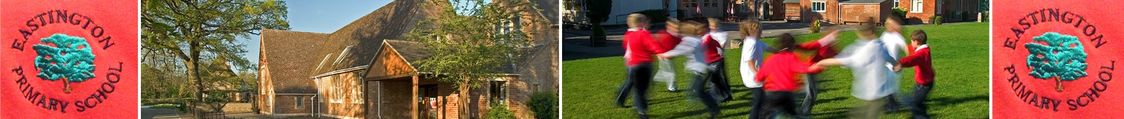

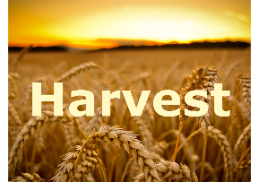

13th October 2020
Dear parents/carers,

Life is not quite ‘normal’ but we have so much to be thankful for. At this time of the year we take time to give thanks for our food and all those who produce it. We are fortunate to live in an area where children see crops and fruits grow and harvested which helps too.

Harvest at school is happening – albeit in a different way this year. The classes have prepared a short Harvest item (a song or poem etc) which Mr Dougan will record this week. Next week, we will enjoy the contributions the classes have created with a Harvest assembly (zoomed) on Thursday 22nd which is our last day together before we break for the October half term holiday. We will also take the opportunity share our sincere respect and thanks to Mrs Lord for her wonderful years of service to the children in Eastington.

Mr Dougan hopes to be able to share the harvest recording that your child has taken part in with you so you can enjoy them at home too. We will contact you with details of this when recording is complete.

As a school we usually collect and give Harvest items to our local food bank in Stroud – we know the extraordinary situation we are in has meant real hardship for many families. If you want to contribute to the collection for Stroud Food Bank we will set out empty boxes at the front entrance in the last week of term (Mond 19th –Thurs 22nd Oct). Please do not send in fresh good as the Food Bank cannot store these. The items the food bank particularly wants are:
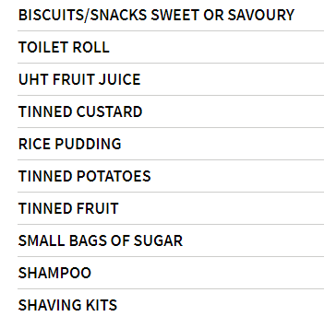
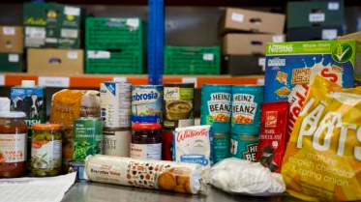

I will drop off our harvest collection to the Stroud Food Bank as soon as possible so it can be used to support families in these difficult times.

With kind regards,

Zoe Avastu
Headteacher

