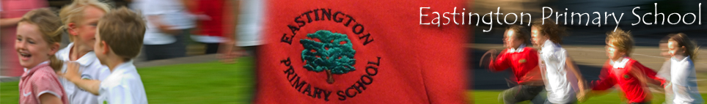

18.12.2020
Dear parents and carers,

This term has been brilliant, though we haven’t managed to carry out all our usual traditions there has been plenty of Christmas spirit and generosity within and the school and local community.

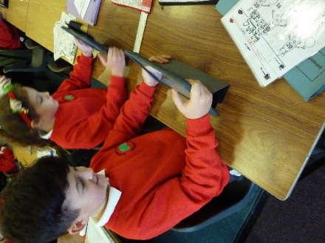
Thank you to the children for being brilliant learners. They have shown how much they enjoy learning new skills and knowledge inside and outside the classroom. We have new ipads and laptops in school and the children have been enjoying coding on them as well improving times table recall and spellings.
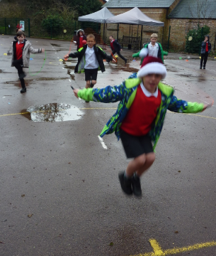
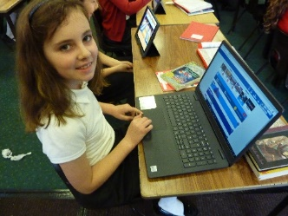
Brilliantly, Violet, Mila, Katie and Mr Dougan have been teaching friends how to skip at break time – lots of children have mastered this skill now and are feeling jolly proud of themselves. Especially well done to Gabriel who showed real resilience.
Cooperation has been a real feature of this term – children cooperating with other children and with their teachers. It has been wonderful to see how embedded this key skill is in our school.

The children enjoyed seeing the performances of their friends/siblings in different classes and in our final assembly today we sang our two special Eastington Christmas songs via Teams. Though we did not manage to end the song at the same time we enjoyed the fun of trying! Thank you to the teachers for organising some Christmas fun this week. I’ve seen balloons, wreaths, Viking boats, model vehicles and I think the Polar Express made a visit to Class 1 too!
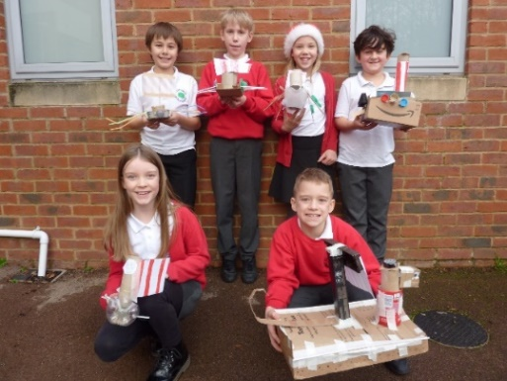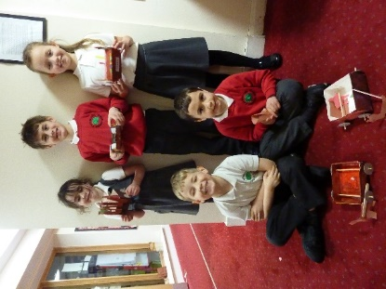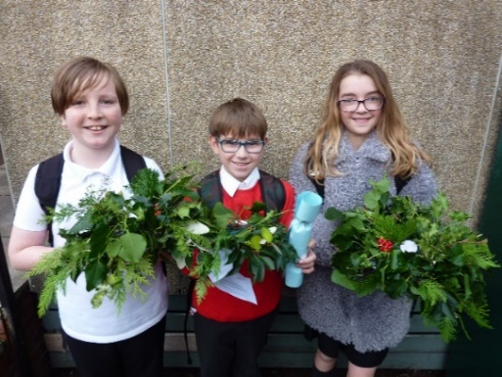

Thank you to Mrs Walton and Mrs Hayward for organising the wonderful Christmas treat bags for the children – they engendered many a smile! Mrs Hussey, the PA team and the village have also helped to organise a brilliant online market and a wonderful advent walk around the village – thank you to everyone who has contributed and donated.

The teachers have really appreciated your support and your good wishes over the term. We are all so pleased to be working with our children in person. Thank you for supporting us in protecting the school well this term by following our Risk Assessment and the National Guidelines – we are thrilled not have had to repeatedly shut classes/move to remote learning. We look forward to seeing you and the children again on Tuesday January 5th for another positive term of learning and fun.

I hope you all are able to enjoy Christmas and spend time with some of your family and friends. With kind wishes to you all for a very Merry Christmas and a Happy New Year!

Zoe Avastu
Headteacher

